**Project writeup : E-commerce Website for Sporty Shoes**

This document contains contents of:

1. Project Description.
2. Sprint planning
3. Flow of the Application
4. Core concepts used in project
5. Conclusions.

**1.Project Description:**

1.Creating a web application that :

1. Manage the products in the store including categorizing them. Categories include adding new category in the list.
2. Browse the list of users who have signed up and be able to search users. Viewing the list of users.
3. Adding the new product details of the Category.
4. See purchase reports filtered by date and Category.

**2.Sprint Planning:**

The project is planned to be completed in 2 sprints.

Tasks assumed to be completed in the sprint are:

1. Initializing git repository to track changes as development progresses.
2. Creating the flow of the application
3. Writing the Dynamic web project program to fulfill the requirements of the project.
4. Testing the Dynamic web project program with different kinds of User input.
5. Pushing code to GitHub.
6. Creating this specification document highlighting application capabilities, appearance, and user interactions.

**3.Application Flow:**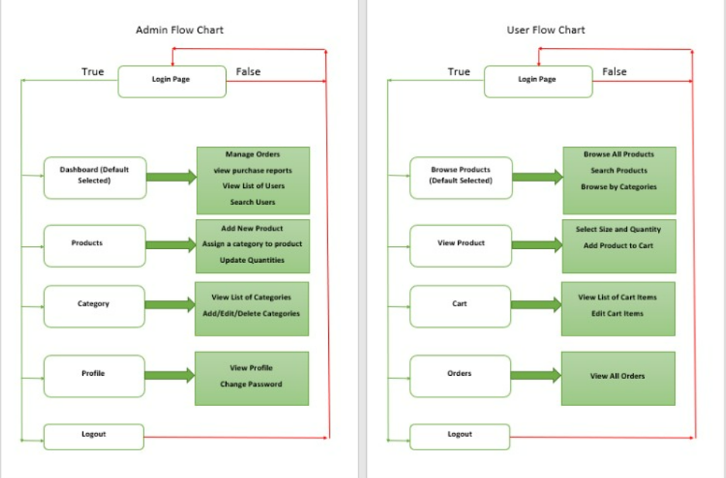

**4.Core concepts used in project:**

1.Build the Maven webproject.

2.Spring boot ,mysql, hibernate concepts

**5.Conclusion:**

This project is designed for creating an E-commerce website for sporty shoes.